**WAD Assignment 2**

<!DOCTYPEhtml>

<htmllang="en">

<head>

<scripttype="text/JavaScript">

functionfun()

{

constmyObj={Email:document.getElementById("inputEmail4").value,

Password:document.getElementById("inputPassword4").value,

Address:document.getElementById("inputAddress").value,

City:document.getElementById("inputCity").value}

constmyJSON=JSON.stringify(myObj);

localStorage.setItem("formJSON",myJSON);

}

</script>

<body>

<formaction="second.html">

<formclass="row g-3">

<divclass="col-md-6">

<labelfor="inputEmail4" class="form-label">Email</label>

<inputtype="email" class="form-control" id="inputEmail4" />

</div>

<divclass="col-md-6">

<labelfor="inputPassword4" class="form-label">Password</label>

<inputtype="password" class="form-control" id="inputPassword4" />

</div>

<divclass="col-12">

<labelfor="inputAddress" class="form-label">Address</label>

<inputtype="text" class="form-control" id="inputAddress" />

</div>

<divclass="col-md-6">

<labelfor="inputCity" class="form-label">City</label>

<inputtype="text" class="form-control" id="inputCity" />

</div>

<divclass="col-12">

<divclass="form-check">

<inputclass="form-check-input" type="checkbox" id="gridCheck" />

<labelclass="form-check-label" for="gridCheck">

Check me out

</label>

</div>

</div>

<buttontype="submit" class="btn btn-primary" onclick="fun()">Sign in</button>

</div>

</form>

</form>

</body>

</html>

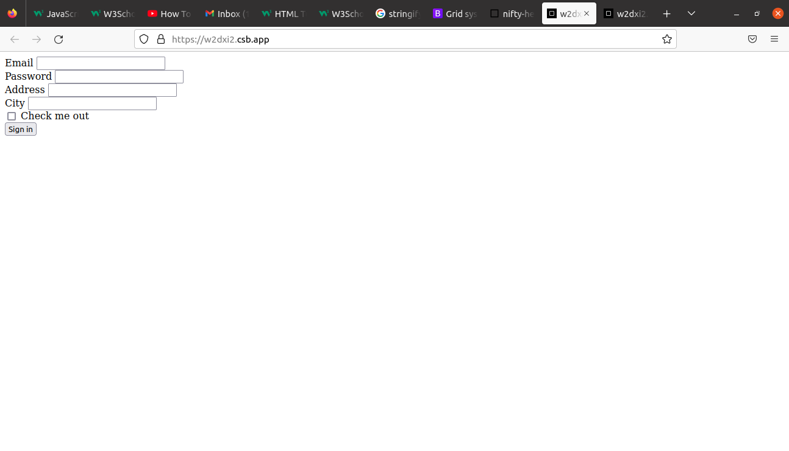

------------------------------------------------------------------------------------------------------------------------

<!DOCTYPEhtml>

<htmllang="en">

<head>

<scripttype="text/JavaScript">

functiondisplay()

{

lettext=localStorage.getItem("formJSON");

letobj=JSON.parse(text);

document.getElementById("abc").rows[0].cells[1].innerHTML=obj.Email;

document.getElementById("abc").rows[1].cells[1].innerHTML=obj.Password;

document.getElementById("abc").rows[2].cells[1].innerHTML=obj.Address;

document.getElementById("abc").rows[3].cells[1].innerHTML=obj.City;

}

</script>

</head>

<buttontype="submit" class="btn btn-primary" onclick="display();">

display

</button>

<pid="xyz"></p>

<tableid="abc">

<tr>

<td>Email</td>

<td></td>

</tr>

<tr>

<td>Password</td>

<td></td>

</tr>

<tr>

<td>Address</td>

<td></td>

</tr>

<tr>

<td>City</td>

<td></td>

</tr>

</table>

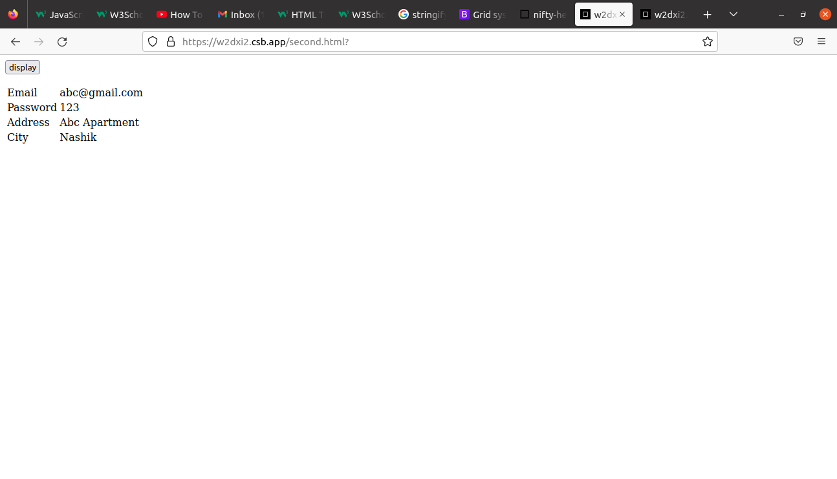</html>